Name:

/37

**Year 10 Science**

**Evolution and Natural Selection Test**

1a. All dogs belong to the one species. How can we tell that all dogs belong to the one species?

2

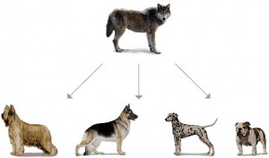

All dogs have a common ancestor. Modern dog breeds have been formed by artificial selection.

1b. What is artificial selection? 3

1c. How did this lead to the large number of different dog breeds we see today. 2

[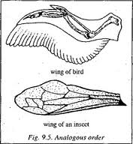](http://www.google.com.au/imgres?hl=en&biw=1920&bih=931&tbm=isch&tbnid=qgy3c1MyVcMajM:&imgrefurl=http://quizlet.com/5221991/evolution-flash-cards/&docid=ywgwHXs98DVxHM&imgurl=http://o.quizlet.com/i/LZHPNT2-8xI_SASFmZ5SrA_m.jpg&w=222&h=240&ei=IBteUYeMJ4XmiAeWw4C4Bg&zoom=1&ved=1t:3588,r:38,s:0,i:215&iact=rc&dur=2079&page=2&tbnh=169&tbnw=156&start=27&ndsp=39&tx=98&ty=88)2a. Insects and birds both have wings. Their wings are considered to be analogous structures.

What is an analogous structure? 2

[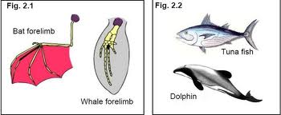](http://www.google.com.au/imgres?start=233&hl=en&biw=1920&bih=931&tbm=isch&tbnid=hRKZzQnlMqsmkM:&imgrefurl=http://acjc-bio-1112.wikispaces.com/1SC7+Grp+2&docid=Mc4xMvu85dAfkM&imgurl=http://acjc-bio-1112.wikispaces.com/file/view/evo.JPG/246198899/639x264/evo.JPG&w=639&h=264&ei=0BteUdSVHbCUiQe3v4D4Aw&zoom=1&ved=1t:3588,r:38,s:200,i:118&iact=rc&dur=2989&page=7&tbnh=142&tbnw=344&ndsp=42&tx=111&ty=79)2b. Bats have wings as their forelimbs, whales have flippers as theirs. Their forelimbs are homologous structures.

Explain what a homologous structure is. 2

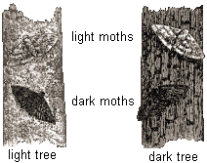Peppered moths live on the trunks of trees in England. The moths are eaten by birds. Like humans some moths are light coloured and some are dark coloured. Long ago light coloured moths were more common

When lots of factories were built in the 1800’s pollution killed the light covered lichen on the bark of the trees near the factories and all those trees became dark.

By 1895 around 98% of moths living near cities with factories were dark.

Today there are regulations to stop factories releasing so much pollution and the light coloured lichen has regrown on the trees.

3a Explain why the dark moths became more common by 1895 2

3b. Do you think there are more light or dark moths today? Explain why you think this. 3

3c. What type of selection is this? 1

3d. What is the selective agent in this case? 1

4. There are three steps in speciation. List them in order. 3



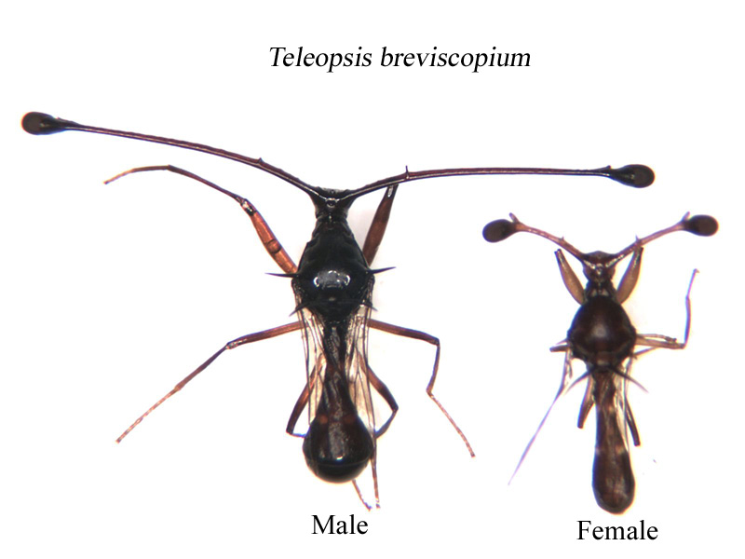This is a picture of a male and female stalk eyed fly. Their eyes are on the end of long stalks.

Longer stalks take a lot more energy to carry around and do not appear to show any particular advantage. However it has been shown that males with longer stalks are more likely to mate with a female. Female stalk length does not affect the likelihood of a female mating.

5a Suggest a reason why males with longer stalks are more likely to mate than males with shorter stalks. 2

5b What is the term used for this type of selection? 1

6. List 4 pieces of evidence for evolution 4



7. Write the correct term for each of the definitions below: 10

*Biodiversity, evolution, speciation, distribution, generation, variation, embryology, Charles Darwin, comparative anatomy, protein structure,*

The time between when an individual is born and when they have their own children.

A genetic change in the characteristics of a species over many generations resulting in the formation of a new species.

Differences between individuals of the one species.

The scientist who is credited with coming up with the idea of Natural Selection

The number and range of different species that exist

The process by which one species splits into two or more separate species

Comparing the structures of different species, both living and those of fossils.

The order of the amino acids within a protein

The study of the development structure and function of embryos

The area over which all the individuals of a species are found

Name:Solutions

/37

**Year 10 Science**

**Evolution and Natural Selection Test**

1a. All dogs belong to the one species. How can we tell that all dogs belong to the one species?

1 Reproduce 2

1 Fertile Offspring

All dogs have a common ancestor. Modern dog breeds have been formed by artificial selection.

1b. What is artificial selection? 2

1. Humans
2. Choosing which individuals breed
3. Based on desired characteristics

1c. How did this lead to the large number of different dog breeds we see today. 2

Any suitable explanation

2a. Insects and birds both have wings. Their wings are considered to be analogous structures.

What is an analogous structure? 2

1 structures that look the same/perform same function

1 genetically different or of different origins

2b. Bats have wings as their forelimbs, whales have flippers as theirs. Their forelimbs are homologous structures.

Explain what a homologous structure is. 2

1 Structures that may look different/have different function

1 but have same origins/similar structure

Peppered moths live on the trunks of trees in England. The moths are eaten by birds. Like humans some moths are light coloured and some are dark coloured. Long ago light coloured moths were more common

When lots of factories were built in the 1800’s pollution killed the light covered lichen on the bark of the trees near the factories and all those trees became dark.

By 1895 around 98% of moths living near cities with factories were dark.

Today there are regulations to stop factories releasing so much pollution and the light coloured lichen has regrown on the trees.

3a Explain why the dark moths became more common by 1895 2

1. Light moths were easy to see/ dark moths were camouflaged
2. Dark moths had more offspring

3b. Do you think there are more light or dark moths today? Explain why you think this. 3

Light moths

Light more camouflaged/dark easier for birds to see

Light have more offspring

3c. What type of selection is this? 1

Natural Selection

3d. What is the selective agent in this case? 1

Birds

4. There are three steps in speciation. List them in order. 3

* Variation
* Isolation
* Selection

Longer stalks take a lot more energy to carry around and do not appear to show any particular advantage. However it has been shown that males with longer stalks are more likely to mate with a female. Female stalk length does not affect the likelihood of a female mating.

5a Suggest a reason why males with longer stalks are more likely to mate than males with shorter stalks. 1

Females prefer longer stalks

5b What is the term used for this type of selection? 1

Sexual Selection

6. List 4 pieces of evidence for evolution Any 4 4

* Fossils
* Comparative Anatony
* DNA
* Protein Structure
* Distribution of Species
* Embryology

7. Write the correct term for each of the definitions below: 10

*Biodiversity, evolution, speciation, distribution, generation, variation, embryology, Charles Darwin, comparative anatomy, protein structure,*

Generation The time between when an individual is born and when they have their own children.

Evolution A genetic change in the characteristics of a species over many generations resulting in the formation of a new species.

Variation Differences between individuals of the one species.

Charles Darwin The scientist who is credited with coming up with the idea of Natural Selection

Biodiversity The number and range of different species that exist

Speciation The process by which one species splits into two or more separate species

Comparative Anatomy Comparing the structures of different species, both living and those of fossils.

Protein StructureThe order of the amino acids within a protein

Embryology The study of the development structure and function of embryos

Distribution The area over which all the individuals of a species are found